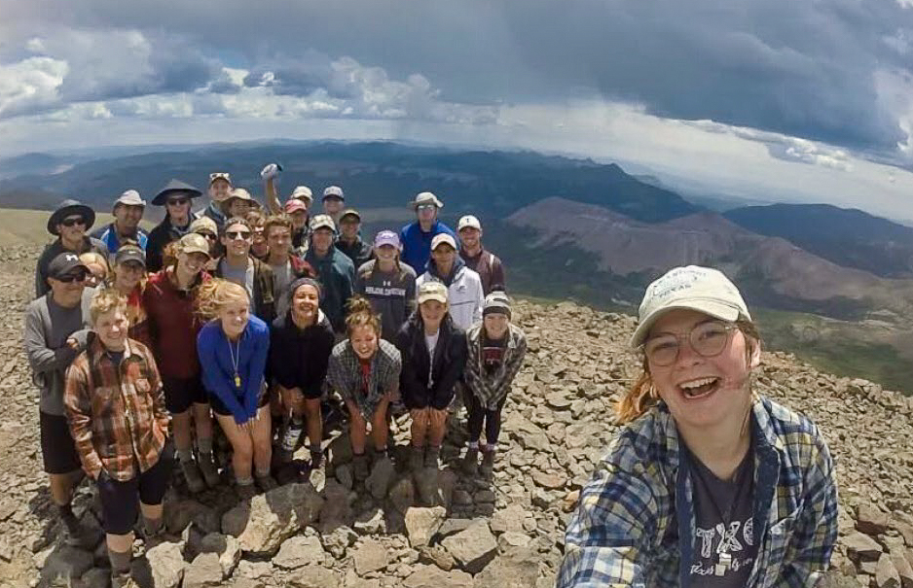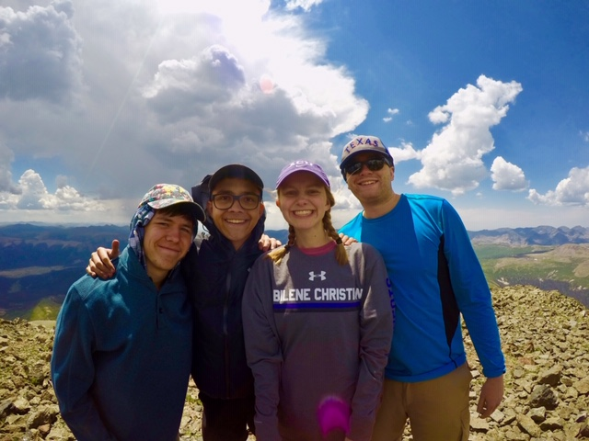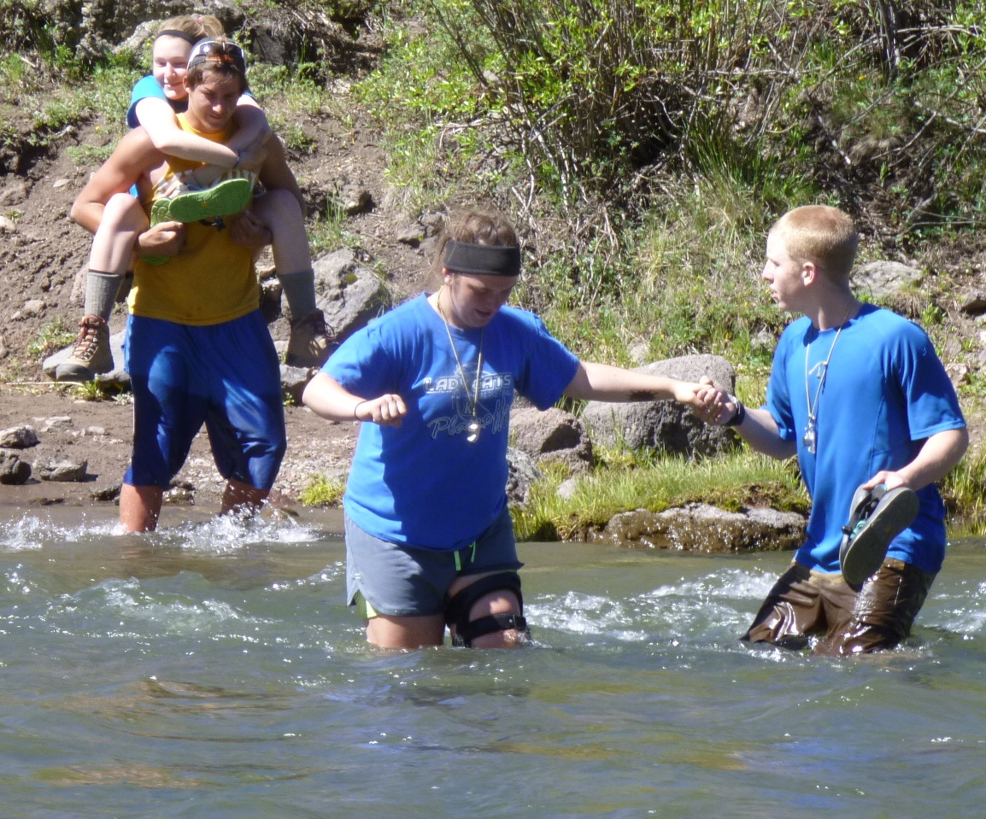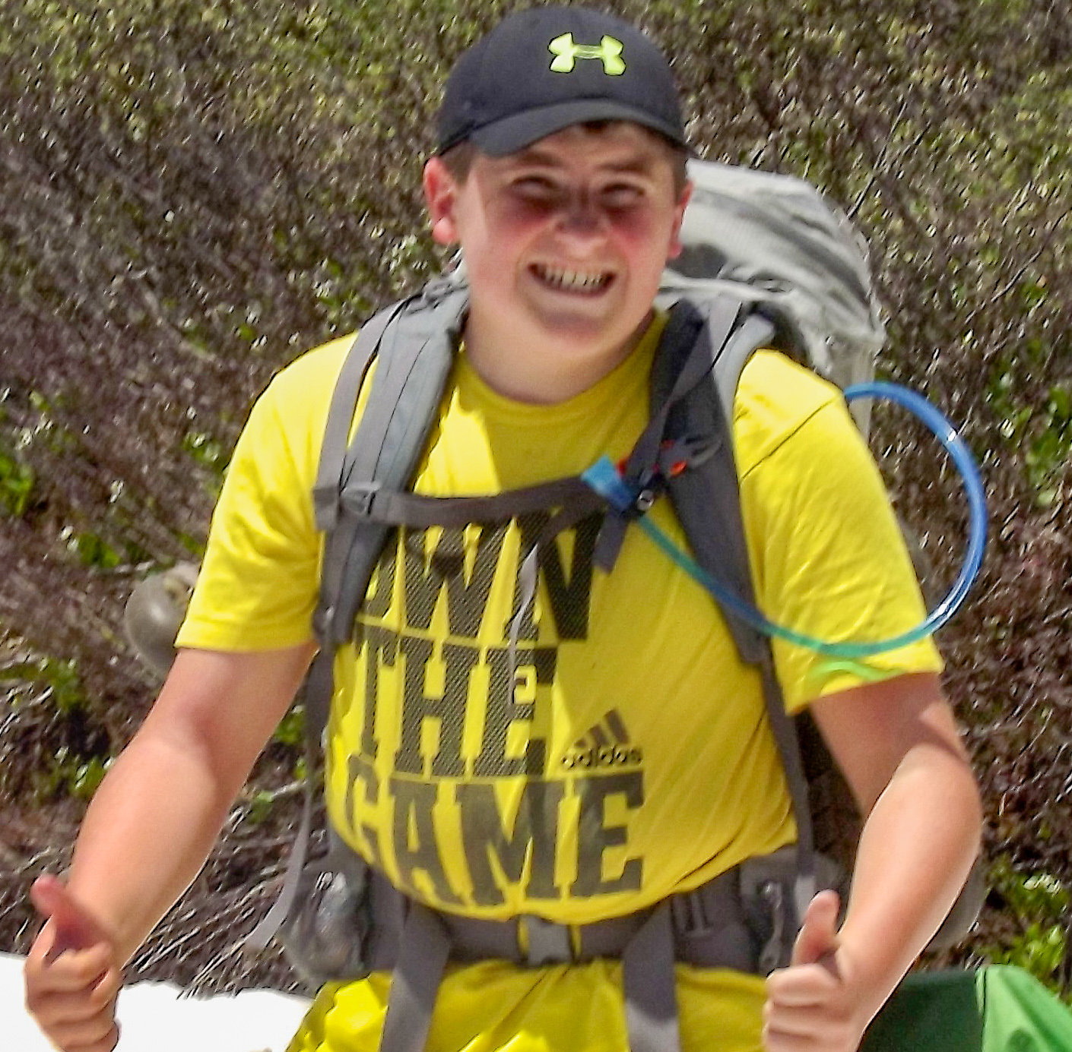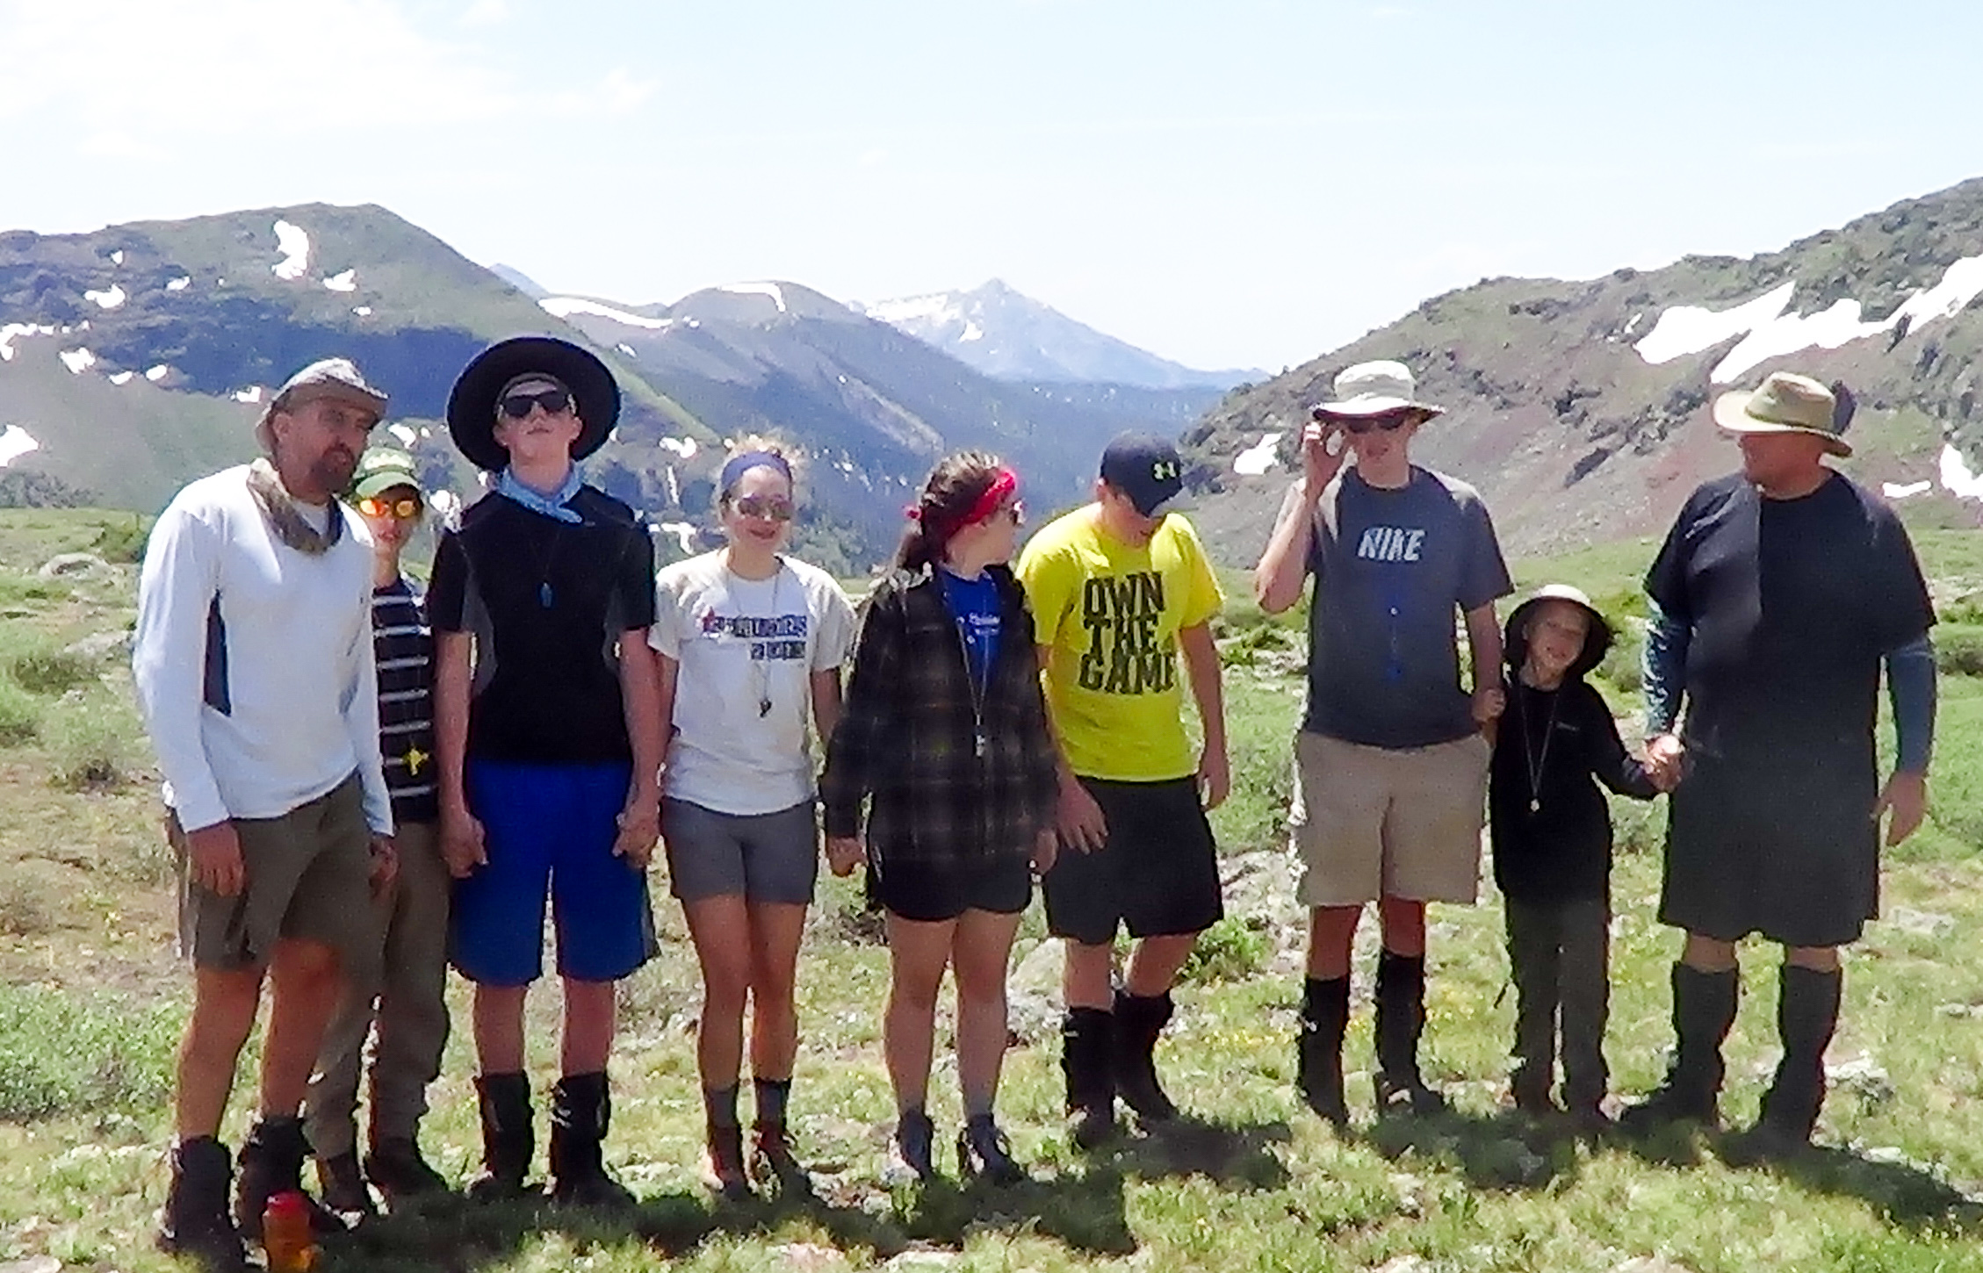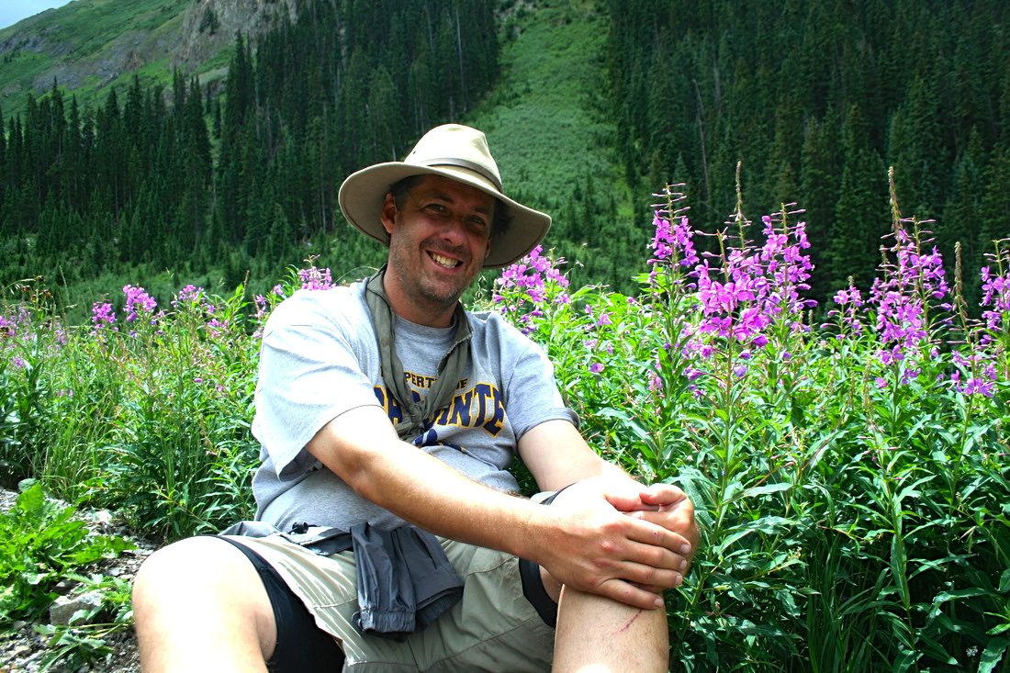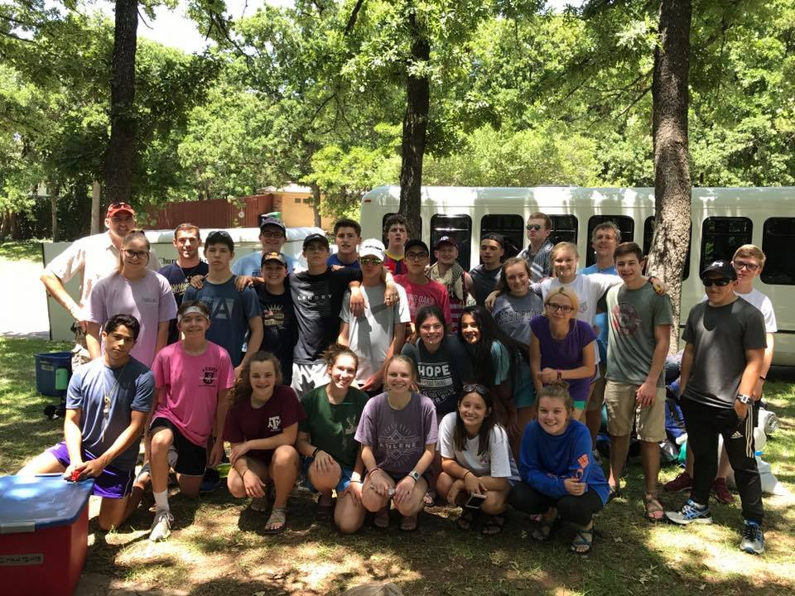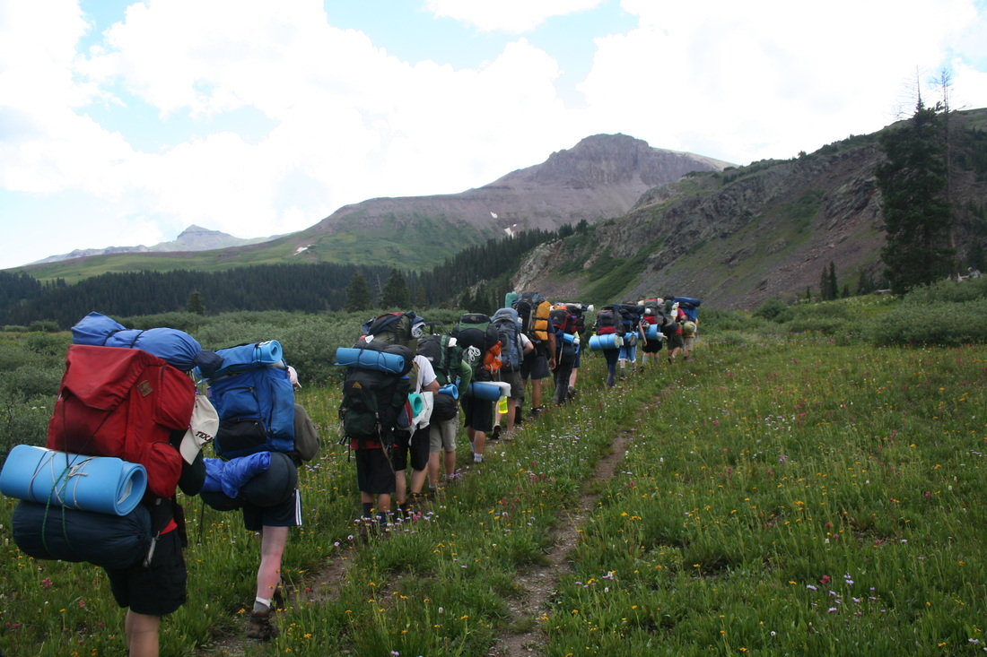

**Cost: $275**

(this total includes the $75 dollar deposit)

Also, each teen will need to bring $40-50 to cover food expenses while driving to Colorado & back. Scholorships will be available for ½, ¾, full amount, and/or meals if needed.

**Supplies:**

**Many of the supplies (ie – backpacks, tents, sleeping bags, pads, cookware, etc) will be provided. The purchase of a pair of hiking boots may be desirable, although some packers just wear tennis shoes. A complete list of clothing supplies will be handed out upon sign-up.**

SOCC YOUTH - For more information contact MIKE FARLEY at 817 522-2605

HIGHER GROUND BACKPACKING TRIP PERMISSION FORM

Do to the nature of the Higher Ground trip, a event specific medical release form is required for all teens. This form will be given to the teen at sign up and must be completed by a physician, and maybe substituted by proof of completion of a Sports physical. Reservations will be contingent on completion of this Higher Ground Medical Consent Form and will be forfeited if such form is not completed and submitted by June 15th. If spots are full you will be placed on a waiting list.

* Journey to Colorado for a week of backpacking, hiking, singing, campfires, devotionals, and enjoyment of God’s creation.
* Grow closer to God and to each other.
* Be challenged to discover a stronger self-confidence, self-esteem, and personal faith.
* Have tons of fun enjoying rugged days in the outdoors.

## We’re going to do What?

THIS EXPEDITION THROUGH THE MOUNTAINS OF COLORADO IS A LIFE CHANGING EVENT. YOU WILL LEARN ABOUT THE OUTDOORS; PHYSICAL FITNESS WILL HAVE NEW MEANING TO YOU; YOU WILL DISCOVER NEW ATTITUDES IN YOURSELF AND IN OTHERS; YOU WILL MAKE NEW FRIENDS AND STRENGTHEN OLD FRIENDSHIPS; MOST IMPORTANT, YOU WILL GROW SPIRITUALLY AS YOU BECOME PART OF THE TEAM, SERVING ONE ANOTHER AND AS YOU DRAW CLOSER TO GOD WHILE SURROUNDED BY THE BEAUTY THAT HE PUT HERE.

COME JOIN US!

HIGHER GROUND TRIP

July 19 -28 (Fri – Sun)

2019

COST: $275

Turn in your $75 deposit with your application to Beau or Mike Farley

817 522-2605

Limited Space!

To see pictures from previous years & info :

HigherGroundBackpacking.com

I give permission for _________________________ to participate with the Singing Oaks Church of Christ Youth Ministry in Higher Ground, the backpacking trip to Colorado. In the unlikely event of an emergency, I give permission for my child to be treated by an accredited physician in an approved emergency clinic or hospital. I further release from liability the Singing Oaks Church of Christ and the adult leaders in the event of any accident en route, during and returning from the activity.

PARENT OR GUARDIAN SIGNATURE _________________________________________

DATE: ___________________

$75 PAID CHECK #_____________ CASH _______________